Task No & Title:  Unit 7 | Unit Descriptor Unit Descriptor This unit covers preparation and production of short routine letters, notes, memos and records using word processing software
Title: | BSBCMN213A Produce simple word processed documents
Suitable for Classes: | Certificate II Business
Area: | Technology & Enterprise
Teacher: | Mr Peter Faulks
Timeline | 1 Lesson
Date Due: | Today

Task Brief:

Files Required

Items highlighted in yellow are tasks for you to complete
Items in Purple are help tips

Unit | Number | Title | Study Time
1 | BSBCMN201A | Work effectively in a business environment | 20
2 | BSBCMN202A | Organize and complete daily work activities | 15
3 | BSBCMN203A | Communicate in the workplace | 30
4 | BSBCMN204A | Work effectively with others | 20
5 | BSBCMN205A | Use business technology | 30
6 | BSBCMN211A | Participate in workplace safety procedures | 15
7 | BSBCMN213A | Produce simple word processed documents | 40
8 | BSBCMN214A | Create and use simple spreadsheets | 20
9 | BSBCMN108A | Develop keyboard skills | 40
10 | BSBCMN107A | Operate a Personal Computer | 20
11 | ICAITU013C | Integrate Commercial computer packages | 30
12 | ICAITU012C | Design Organizational Documents using computer | 50
 |  | TOTAL

Typing Speed Tests
Gain at least 40 WPM print screen showing your score and add it to this page. Then take a test as instructed by your teacher. Test 3 Minutes
http://speedtest.10-fast-fingers.com/
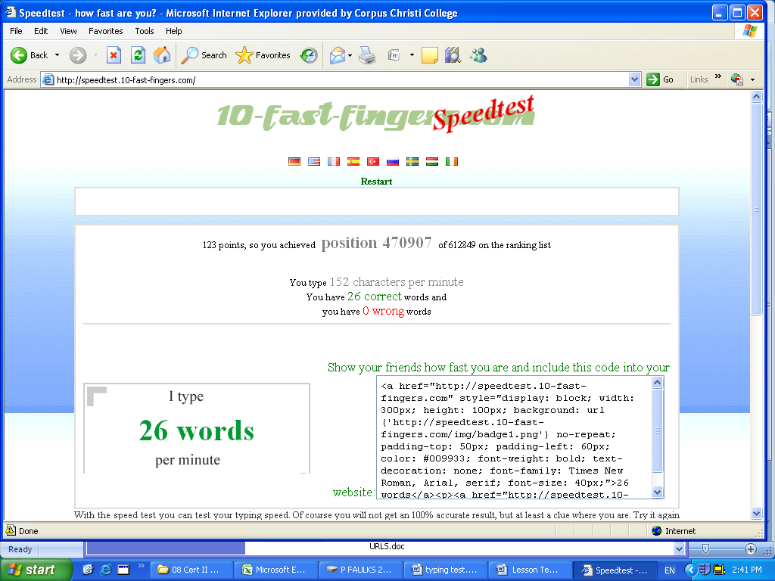

TYPING TEST

After completing training

http://www.goodtyping.com/default.htm

When instructed to do so
Type the requested document you have three minutes to type
When stop is called
Hit tools word count and print screen

For marks look up 07_04 Typing_Speed_Test.xls

Test 1 Type the following you have three minutes to type the hit tools word count and print screen when STOP is called

The Grand Prix

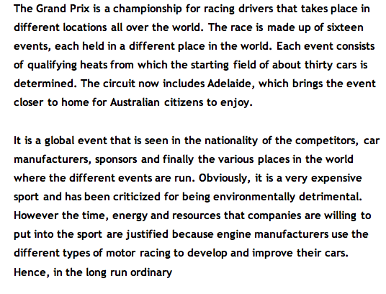

Screen shot of word count
Test 2 Type the following you have three minutes to type the hit tools word count and print screen when STOP is called

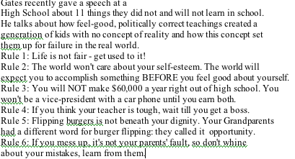

Screen shot of word count
TEST 3 Type the following you have three minutes to type the hit tools word count and print screen when STOP is called

Perth Western Australia

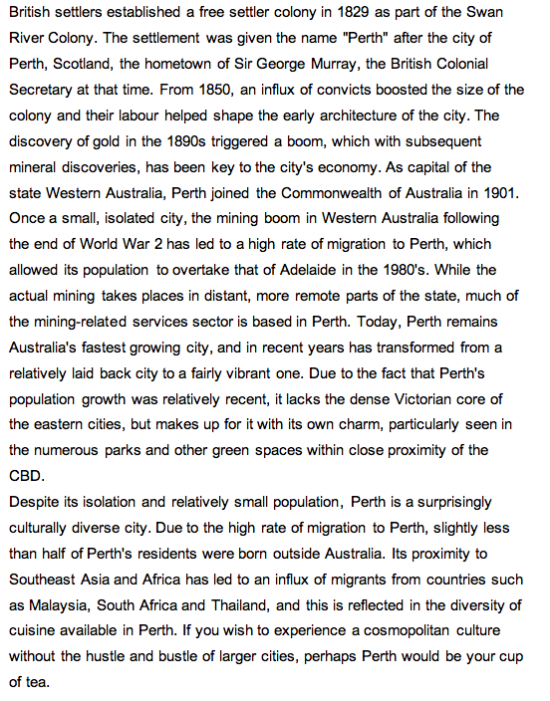

Screen shot of word count

TEST 4 Type the following (Correct to Exactly copy the following)
You have three minutes to type, the hit tools word count and print screen when STOP is called

Life in School

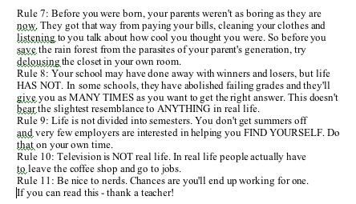

Screen shot of word count

Typing Test on line

http://www.goodtyping.com/default.htm

Save the work

Student Name: | Date submitted:
I declare this evidence to have been produced by me the undersigned.

Candidate’s signature:
Title of Portfolio evidence presented Enter title here
BSBCMN213A Produce simple word processed documents Section 07:???
□ Outcomes from learning programs (including self-learning and online learning)
□ Assessment feedback (from a trainer or assessor)
□ Observation checklists (from a workplace supervisor or assessor)
□ Written statements or references (including workplace supervisors, community leaders)
□ Job descriptions
□ Work journal
□ Work samples
□ Finished products
□ Product descriptions or specifications (supporting the product samples included)
□ Statutory declarations
□ List others (or delete any from above not provided)
- All work submitted to be word processed and spell checked.
- There must be at least two samples of evidence for each
Element within the Unit of Competency. This is sample 1 / 2
- All work submitted must be of a high quality and meet the
requirements of the Unit of Competency.
Other evidence (List each piece):
Assessor to complete
Evidence is Valid Sufficient Authentic Current
□ □ □ □

Assessor signature: _________________________________Date: _____________
Peter Faulks, BA Soc Sci, Grad Dip Ed, Cert IV AWT
Certificate II in Business assessor/teacher
Assessor to complete

Student is declared Competent Not Yet Competent
□ □

Keep a copy of this report with your file for evidence

